Dear Principal and Chair of Governors
Urgent Call to Action: Shape the future of our controlled schools
We are writing to ask you, as a controlled school Principal, to respond to a critical consultation on the future of the controlled sector and to share it with your governors and wider school community (by 11 December).
We are principals who participated in the Ministerial Taskforce on support for controlled schools.

The Taskforce identified the need for strategic leadership and focused equitable support for the sector, to address the current shortcomings. We need you to respond to this consultation, which represents a historic opportunity to secure dedicated support for controlled schools, addressing the long-standing challenges and ensuring equity with other sectors.

The Department of Education has agreed with the two-phased approach recommended by Taskforce:
- Phase 1 - Establishing a Controlled Schools Unit within the Education Authority
- Phase 2 - Creating a dedicated organisation through legislation
The Taskforce report stated, ‘A roadmap has been developed to outline this phased strategy, balancing immediate action with ongoing development… The Taskforce’s concurrent approach addresses systemic challenges and establishes a foundation for more equitable support for controlled schools.’
As leaders of controlled schools, our voices are crucial in developing a strategic approach that will benefit every child. By responding, you can create a more focused, supportive educational environment that recognises the unique strengths and needs of the sector.
Together we can drive meaningful change and ensure controlled schools continue to thrive and provide high-quality, inclusive education for all.
Please respond by visiting www.csscni.org.uk/shape-the-future-of-controlled-schools before 11 December 2025.

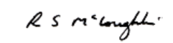  Banbridge Academy | 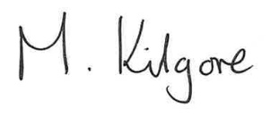Drumachose Primary School | 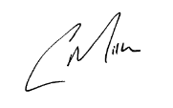  Fort Hill Integrated College
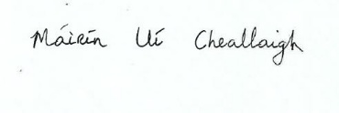Gaelscoil Neachtain | 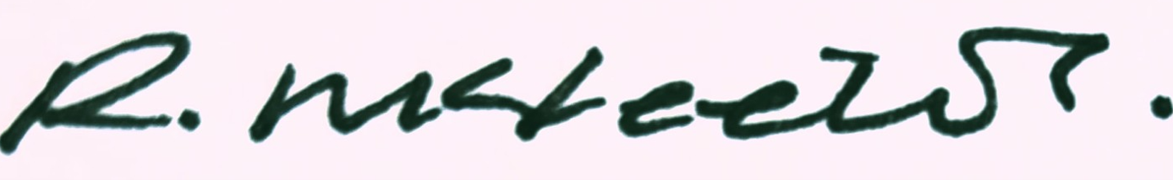  Hill Croft Special School |   Kilkeel Nursery School
Largymore Primary School |   Limavady High School | 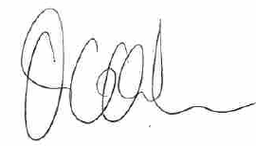  Regent House
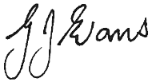 | 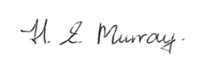  Millington Primary School
Cookstown High School

