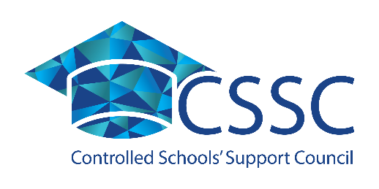

**Position paper: Addressing misperceptions of the controlled sector**

**It takes a community to educate a child.**

The controlled sector includes every type and phase of school, with a mix and blend of pupils as diverse as are the communities in our country. CSSC welcomes and supports all controlled schools, whether they be special, nursery, primary, selective or non-selective post primary, integrated or Irish-medium. Some controlled schools draw their pupils predominantly from one of our traditions, some are very mixed, while others have pupils who are mostly from new-comer communities. This is only to be expected of schools that are embedded in, serve and are connected to their local communities.

Controlled schools are open to all, this is a statement of fact as well as a challenge. The ethos of the sector clearly states that controlled schools are open to all faiths and none, in providing high quality education for children and young people to enable them to learn, develop and grow together, within the ethos of non-denominational Christian values and principles.

On behalf of all controlled schools, CSSC advocates for:

* High quality education for our children and young people preparing them to contribute positively to a diverse society.
* Sufficient and equitable funding and support for all schools, their children and young people.
* A network of sustainable schools connected to their communities.
* Effective collaboration between all schools.
* Evidence based legislation, policy and procedure.

These fundamental principles are at the forefront of CSSC’s support and are at the core of the sector. The controlled sector is the sector for the community and for every community - striving to provide high quality education in rural and urban contexts, equal and equitable and collaborative. Our children and young people educated together in a community of schools at the heart of  
their communities.

**A community of schools, for schools serving their communities.**