Roddensvale Ethos Case Study
Roddensvale School’s culture and ethos is developed through a nurturing, attachment and trauma informed approach, where relationships are at the heart of every interaction.
Developing a safe and secure environment
Our purpose at Roddensvale is to provide the most appropriate education for our pupils within a safe and secure environment. We are conscious of the growing body of research and understanding of the impact of Childhood Adversity Experiences (ACEs) on long term mental and physical health, and the protective factors that mitigate the potential impact of ACEs. It is our aim at Roddensvale to by create an environment of safety by maximising these protective factors within school.
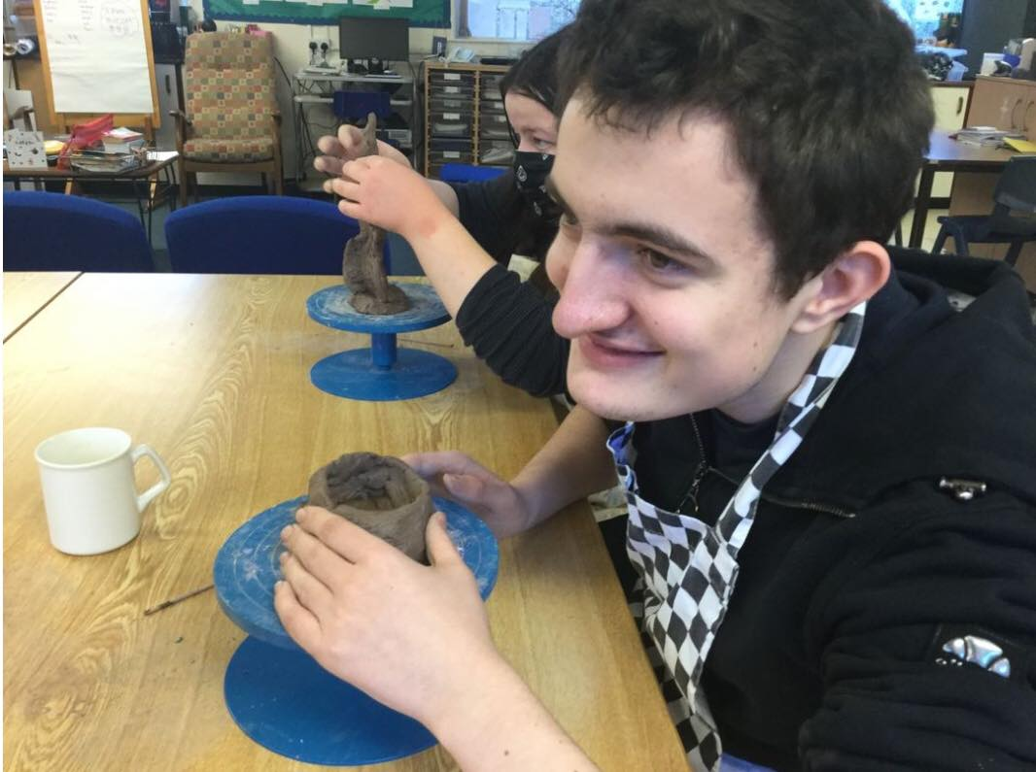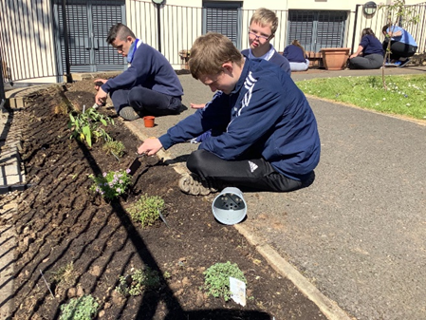
Staff at Roddensvale take a personalised approach to meeting the needs of all children and curiosity about a child’s behaviour is encouraged in order to consider and develop strategies which support emotional regulation. Staff understand the impact that a positive relationship between a child and a trusted emotionally available adult can have in supporting the mental health and resilience of a child who is experiencing difficulties. Pupils are supported to understand their thoughts and feelings and to explore new options and strategies to deal with challenges. Play and creativity are considered significant for all year groups at Roddensvale and there is a recognition that all children flourish when learning and interactions are playful. The school’s play therapist supports children and young people with specific trauma and attachment related difficulties and shares these approaches with staff.

Cultivating a trauma informed approach
As a school we have embraced a wide definition of trauma to encompass any event that is experienced as frightening, painful or out of control. The day-to-day exposure to events such as divorce, loss of a loved one, illness within the family or moving house can be experienced as traumatic for the children in our care. Providing an environment that has safety, connection and compassion at its heart ensures that our school environment never unwittingly re-traumatises any of our school members and acts to maximise protective factors through the conscious use of our relationships.
Supporting our children requires emotionally regulated and available adults who can provide essential calming and containing of our pupils, their parents/carers or each other when they are overwhelmed by an event, a situation or their feelings. In our school the emotional well-being of and emotional regulation of staff is considered highly important to prevent burn-out, stress–related absence, or leaving the profession as a result of stress-related illness, secondary trauma and/or feeling blamed or under-valued. Training and workforce development is therefore prioritized and debriefing opportunities provide staff with the opportunity to reflect and recover from managing situations that have caused or may cause distress.
Embedding good practice
Developing a trauma informed approach requires a significant commitment and we are under no illusion that this will happen overnight. We are constantly evaluating our actions and working with others to assess gaps and opportunities, to identify where interventions are needed at the earliest point. Our work to date, which has involved training for staff from Dr Jenny Nock, has resulted in the achievement of the Bronze and Silver Awards for Attachment and a Trauma Sensitive School. To ensure that this trauma informed approach becomes embedded within our school ethos we have established an Advisory Group with the SBNI, EA, CSSC and the NHSCT to ensure we are engaging with the right stakeholders at the right time to improve and ensure best outcomes for our children. The Advisory Group is a means of ensuring that everyone who works with and supports the school develops an understanding of childhood trauma and adversity and how it can affect children, young people and their families. We monitor and evaluate every intervention to understand what is working well for the child and to identify any gaps or opportunities to improve provision for the child.
As we continue to embed trauma informed practice within our school ethos we will apply the trauma lens to ensure that the approach is reflected in all policies and procedures and that the school’s ethos is communicated on a daily basis through the child’s lived experience of the values that support an environment which recognises and celebrates all children’s achievements.

