Cookstown Nursery School – ethos journey
After a period of transition including a new Principal, staffing changes, the reconstitution of the Board of Governors and a new three-year cycle of the school development plan, it was the ideal time for Cookstown Nursery School to create an ethos which was truly reflective of ‘our’ school.
A collaborative approach to ethos development
We knew the best approach was a collaborative one which incorporated the views of all stakeholders - parents, staff, governors and importantly the children. Our first step was to have an ‘Ethos Workshop’ supported by CSSC and attended by staff, governors and parent representatives.
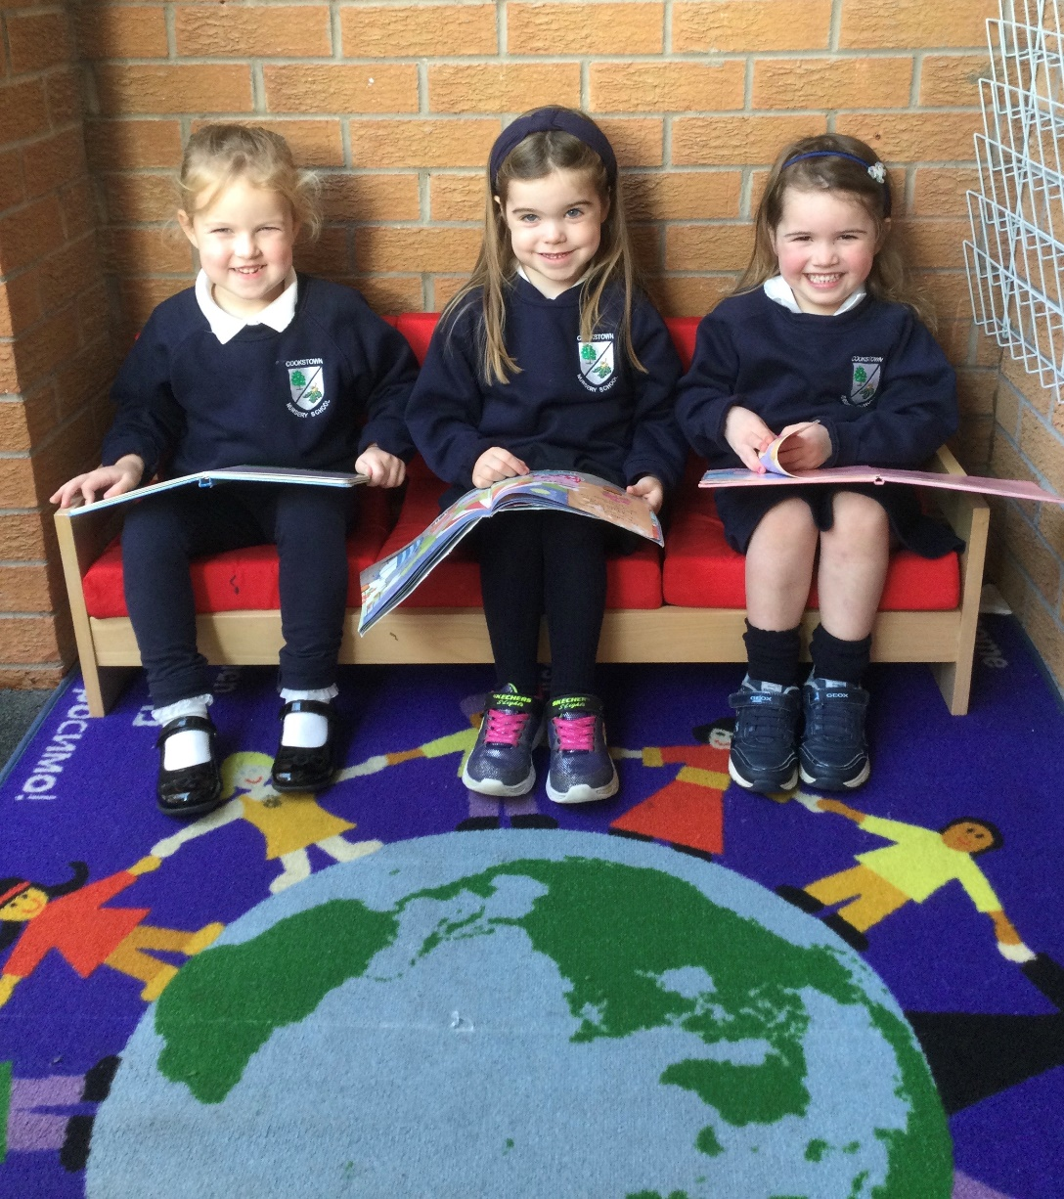
This event was an excellent opportunity for everyone involved to build and strengthen relationships and share thoughts and ideas on what our school really meant to them. We discussed some of the responses received from the previous end of year questionnaires from parents, staff and governors. We also considered the voice of the children gathered from various means including conversations, focus groups and video clips.
We began by considering the words which best described our school. Words like ‘warm’, ‘welcoming’, ‘happy’, ‘safe’, ‘nurturing’. By the end of the process we created our ethos statement:
“At Cookstown Nursery School, together we aim to provide a warm and welcoming environment where everyone in the school community will feel safe, respected and valued. Children will be nurtured, respected and encouraged to achieve their aspirations and become life-long learners.”
The workshop served as a rewarding and fulfilling experience which gave the opportunity for staff, governors and parents to work together. We shared our ideas and thoughts about our school with the best interests of our children being at the heart of all our efforts.
Embedding ethos across the school
In the years since, we have continued to follow and build upon our ethos in everything that we do. We feel fortunate to have the opportunity to create a welcoming, happy and nurturing learning environment for all our learners. A place where children can feel safe and secure whilst building meaningful relationships with adults and children around them.
All children are encouraged and supported in their learning. Praise and positive reinforcement is a key strategy in developing self-confidence and independence. Learning opportunities are well planned, take account of the children’s interests and are presented in a fun and meaningful way. The children’s achievements are celebrated both within school and at home.
The staff are happy, feel supported and respected within their working environment. Opportunities exist for training and development of skills. Regular collaborative discussions between staff allow for sharing of ideas and ensure relevant school information is disseminated regularly.
Management and staff are supported by a team of dedicated governors, who show genuine interest in the well-being of everyone in the school. They participate regularly in key school events and are always on hand for advice and guidance should it be required.
We have established good relationships with our parents by ensuring two way communication, sharing our aims and values and promoting a collaborative learning approach between home and school.
We are well established within the community we serve and strive to make links with local organisations to support our children and families. Our parents value the opportunities open to them to build the skills and confidences to better support their children.
Ethos is the ‘life’ of the school
When we embarked upon this journey, we aimed for an ethos statement which was reflective of our practice and captured the core values of our nursery. Upon reflection, the ethos is the ‘life’ of our school. It is what you see, hear and feel from the minute you enter our building. It is the friendly face which greets children in the morning, the comfort and reassurance given if they are upset and the positive attitudes expressed towards exploration and learning through play. It is reflective in the staff’s attitude and desire to support and encourage the positive behaviours our children need to become independent, happy learners and thinkers. It is the very essence of how we encourage our children to grow and learn.
We are proud of our school and everyone involved in helping to establish a positive first experience of school life for our children and parents.

