Ethos self-evaluation toolkit

Published by the Controlled Schools’ Support Council
E: info@csscni.org.uk
T: 028 9531 3030
W: www.csscni.org.uk

Vision
‘The Controlled Schools’ Support Council supports controlled schools, which are open to all faiths and none, in providing high quality education for children and young people to enable them to learn, develop and grow together, within the ethos of non-denominational Christian values and principles.’

Contents

Foreword 4
The impact of ethos in a school 6
Ballymena’s three bears 7
Every pupil is valued at Hardy Memorial Primary School 9
Ethos and shared education in Limavady High School 11
A primary school ethos journey 13
A whole team approach to ethos development 14
Extra-curricular activities contributing to a school’s ethos 16
Introduction to the CSSC ethos self-evaluation toolkit 17
Engagement wit h stakeholders 17
Evaluation of ethos 17
Consultation 17
How to use the toolkit 19
Figure 1 – Flowchart to guide your school’s ethos journey 20
Baseline activity 21
Part 1 22
Consultation on statement of ethos 23
School Development Session 23
Step by step guidance for leading a school development session 24
Exploration of what ethos is and its importance 24
Mission statement, vision and values – explanation 24
Consideration of what constitutes an ethos - group collaboration activity 25
Challenge 25
The way forward 25
Appendix 1 – Exploring ethos 27
Appendix 2 – Group collaboration 29
Appendix 3 – Ethos statement activity 30
Appendix 4 – Consultation letter 31

Foreword
The Controlled Schools’ Support Council (CSSC) was established in September 2016. One of the key functions of the organisation, agreed by the Executive, was to work with schools within the sector to develop and maintain its collective ethos. Ethos is critical to all aspects of school life, it is the cornerstone on which a school operates and should permeate everything that happens within a school.
The controlled sector as we know it today originated in the early 20th century, when schools managed mainly by the Protestant churches were transferred to the state. Together with schools provided directly by the state, they formed a non-denominational church-related sector delivering free education for all children irrespective of background and inclusive of children of all faiths and none.
Barry Mulholland, Chief Executive
From these beginnings of a historic faith context and a commitment to free public education, today's controlled schools provide for a more pluralist society through a diversity of schools with individual characteristics, but with core values and principles which underpin a belief in high quality education for all, regardless of faith, race, class or philosophical conviction.
The diversity of the sector is evident in the age range of pupils it serves, three to 19, as well as in the types and locations of the schools which it represents. It celebrates the inclusion of nursery, primary, special, and post-primary schools within its wide reaching community, which stretches from the remotest rural locations to the heart of the inner cities. Controlled schools welcome all young people, whoever they are and from wherever they come.
In response to CSSC’s listening events held with Principals and governors during March 2017, CSSC established a working group with representatives from the Transferors’ Representative Council and Stranmillis University College. The working group recommended that further consultation regarding current practice in respect of ethos, values and collective worship should take place with schools.
Extensive consultation was carried out during the 2017/18 academic year across Northern Ireland and with all types of schools within the controlled sector. Analysis of the consultations has led to the development of the CSSC ethos toolkit, which aims to assist schools to develop a statement of ethos. It provides evaluation materials that will assist schools seeking to strengthen their ethos and critically evaluate how it contributes to pupil achievement and well-being.
CSSC has been inspired by the value and importance placed on ethos and is extremely grateful for the contribution from our associate and to the schools who have assisted in the development of this toolkit.
We trust that the CSSC self-evaluation toolkit will be useful to controlled schools and will assist in exploring ethos within individual school settings.

Barry Mulholland
Chief Executive

The impact of ethos in a school

During the development of the CSSC ethos toolkit, the importance of a clear ethos to enable a school to thrive and for pupils to aspire to reach their potential became apparent.

Of course there are many controlled schools across all phases of education living the school ethos on a daily basis, and we hope you enjoy the following case studies that highlight how a number of schools embed ethos in what they do.

Ballymena’s three bears
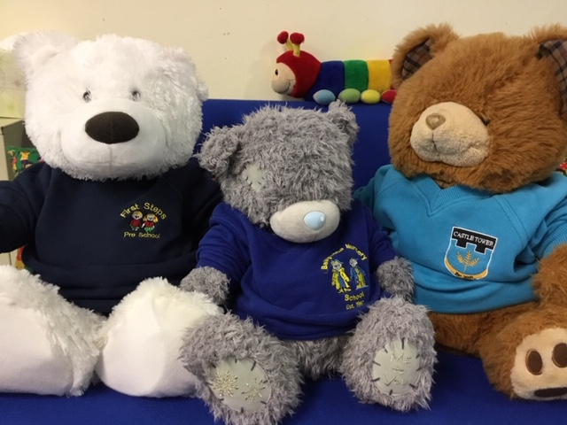
Ballymena Nursery School, 1st Steps Play Group and Castle Tower Nursery Unit have come together with some new friends – the three bears – to celebrate diversity and inclusion, writes Jacqueline Coulter, Principal, Ballymena Nursery School.
Celebrating diversity and inclusion in Ballymena Nursery School has been firmly embedded over the years through initiatives such as CRED (Community Relations, Equality and Diversity), Special Educational Need Inclusion Services (capacity training) and the early years media initiative.
Ballymena’s three bears help celebrate diversity and inclusion
More recently, we entered into a new phase of developing our diversity and inclusion further by joining the staff and children of 1st Steps Playgroup and Castle Tower Nursery Unit in the Sharing from the Start peace initiative from September 2018.
We have enjoyed joint stay and play dates, celebrated Christmas together by having Christmas jumper day and a visit from Santa, and music and movement sessions are planned with ‘Jo-Jingles’, ‘Fun with Drums’ and ‘Beyond Skin’.
Our theme song celebrating diversity and inclusion is sung during every session to the tune of ‘My Bonnie lies over the ocean’ and we are currently learning accompanying Makaton hand signs:
In our nursery we have many children,
We’re different but really the same.
In our nursery we have many children,
And sometimes we share the same name….
But inside, inside, inside our hearts were the same, the same.
But inside, inside, inside our hearts we’re the same.

The common curricular thread is music and movement, while our personal, social and emotional emphasis is helping our children learn that although we may wear different coloured sweatshirts and go to different schools, we are all the same on the inside.
The inspiration for the creation of our three bears came literally from the mouths of babes. The common comment our children made from their Sharing from the Start experiences was that some children had a different sweatshirt than them.

Our three bears are dressed in our three settings sweatshirts, and help us celebrate diversity and inclusion in a child-centred and fun, hands on approach. The three bears are prominently, and naturally, featured in the children’s role play in the home corner. They are offered cups of tea, fed all sorts of imaginary food, talked too, cuddled, hugged and loved by the children.
We often hear the children question the bears by asking, “What’s your name, what school do you go to?”
Sharing from the Start has given the children and staff regular opportunities to make new friends, share and explore new ideas and visit other school settings.
The children talk about their new friends and they enjoy visiting other schools, playing with new toys and sharing their snack, group story, paint, draw, make musical instruments, music and singing and learning to use Makaton signs together.

Every pupil is valued at Hardy Memorial Primary School
‘Preparing Pathways to Fulfilling Dreams’ is our strapline at Hardy Memorial Primary School and is central in the ethos underpinning our school, writes Principal Elaine Anderson. In Hardy Memorial we provide a caring, secure and stimulating learning environment where every pupil is valued.
We have chosen to focus on ‘every pupil is valued’ for the purposes of this report and show what this looks like practically in our school.
‘Every pupil is valued’ is a core part of Hardy Memorial Primary School’s ethos

Learning
The curriculum is well planned with planning time provided for teachers in each year band. Continual evaluation of learning takes place through use of curriculum focus groups with pupils. Marking for improvement provides individualised feedback to children. Teachers use strategies such as WALT, WILF to talk confidently about their own learning. Pupils set their own individual goals and their opinions are valued. A wide range of learning experiences both inside and outside the classroom are offered with preparation for life as the central focus. A comprehensive CPD programme is ongoing and ensures continuous development of learning and strategies to support teaching and learning.
Assessment
Regular meetings take place between the Principal, assessment coordinator, SENCo and class teachers to monitor pupil performance and progress and tailor provision to individual pupil needs. Every pupil’s pathway for learning is important and valued. We have well managed SEN policy and procedures where support is provided for individual pupil need from within school and from external support agencies. Pupils with medical needs are supported and accommodated. Personal learning plans address individual children on the Code of Practice.
Pastoral Care
The physical learning environment provided values pupil’s safety. School grounds have secure fencing, doors are locked and secured and clear procedures are communicated to school community. Comprehensive child protection policies and procedures support and value each pupil’s pastoral needs. Our ethos sees staff providing empathetic care and understanding of a wide variety of individual pupils’ needs and to deal with issues sensitively. Teaching, non-teaching staff and playground pals share collective responsibility for the pastoral needs of all children in our care.
Pupil Voice
We value pupils’ input and opinions through both the Pupil Council and the Eco Council. Class assemblies value pupil contributions. Monthly celebration assemblies celebrate and value pupil success in literacy, numeracy, reading, ICT and helpfulness and good manners.
These are just a few practical examples of ‘every pupil is valued’, in Hardy Memorial Primary School. Although a small aspect of our overall ethos, so many aspects of school contribute to valuing each and every pupil in our care.

Ethos and shared education in Limavady High School
I had the pleasure of meeting with Heather McKenzie from the Controlled Schools’ Support Council to discuss the importance of having a school and sector ethos, writes Darren Mornin, Principal of Limavady High School. This discussion prompted me to reflect on my own school ethos and how it relates to the vision for my school, one heavily involved in shared education.
Limavady High School’s ethos is central to its shared education programme

Ethos is a Greek word meaning “character” that is used to describe the guiding beliefs or ideals of a community. When visitors come to our school they would often say, “you can feel the ethos the minute you walk through the door”.

In Limavady High School our beliefs and values are based around strong Christian morals; this extends throughout all that we do day in day out.

The approach we take as a school to develop and embed these values is articulated through collective worships, not only in school assemblies but on special occasions in our local church facilitated by the local clergy and during our religious education lessons.

Children and staff of all faiths and none are welcome at Limavady High School and our school aims to promote understanding between all members of our school community. Our own core values align closely to Christian values. The values of respect, integrity, personal responsibility, teamwork and fairness were agreed by all our stakeholders and reflect the day to day life in our school.

The Limavady High School community thrives in a positive and happy environment in which there are clear and agreed expectations. For each pupil this is their ‘best chance’ to succeed.

All teachers and support staff represent and project the values of the school, both as a collective body and as individuals. This, in my view, is a vital component in bringing our school ethos to life.

We believe that the shared education programme has enabled us to further develop this ethos by working with our partners St Mary’s Limavady. At present we have nearly 600 pupils in key stage three timetabled on a weekly basis for joint learning for life and work classes.

These classes are taught collaboratively in both schools in mixed classes. The delivery focuses around the topics of local and global citizenship, personal development and education for employability. This enables our pupils to develop the fundamental skills, knowledge, qualities and dispositions that are prerequisites for life and work in a shared setting.

I believe that there are four main concepts when bringing the ethos of a school to life.

- the ethos which is closely aligned to the mission statement needs to be sold as an ideal to all the staff, pupils and all stakeholders in the school.

- The staff need to believe in the guiding principles of ethos or mission statement and feel part of it.

- The third concept, and probably the most important one, is that the ethos needs to extend throughout all that we do.

- The final concept is to build on it and allow it to develop organically.

Developing and establishing the ethos of a school is not something that can happen overnight. It takes time to ensure that it is part of what we do on a daily basis.

A primary school ethos journey
On taking up my position as Principal a number of years ago, I felt it was important to have a consultation process with all stakeholders as to what they understood to be the ethos of the school, writes Corrine Latham, Principal of Seaview Primary School in Belfast.
Giving staff, pupils and parents an opportunity to stop and think about what was the core aim of the school was such a useful process.
Pupils’ voices are valued and respected at Seaview Primary School
We held collaborative staff and governor meetings that focussed on our purpose as an organisation, and conducted questionnaires with staff and parents. Pupils had the chance to express their views through school council meetings, questionnaires and through “Hot Chocolate Friday” with the Principal.
By doing so, every member of staff, pupil and parent developed a confidence in the school, because they knew their opinion was valued. We believe that in order for our school to be successful, everyone has a part to play and everyone must play their part.
In Seaview, we feel and see that the pupils live the school's ethos. We have cultivated this by reinforcing the school ethos in our school assembly, Rights Respecting Schools work and PDMU lessons. The Seaview pupil voice is valued and respected, and we have developed student leadership roles and given the pupils time to contribute to the direction of school travel.
Our values are explicit and displayed in the entrance of our school. We have a Disney-like protocol of naming and noticing behaviours that reinforce our ethos. Children understand from an early age that we care about them and in doing so we have effectively created a nurturing environment for them to grow.
After all, they may forget what you said, but they never forget how you made them feel.

A whole team approach to ethos development
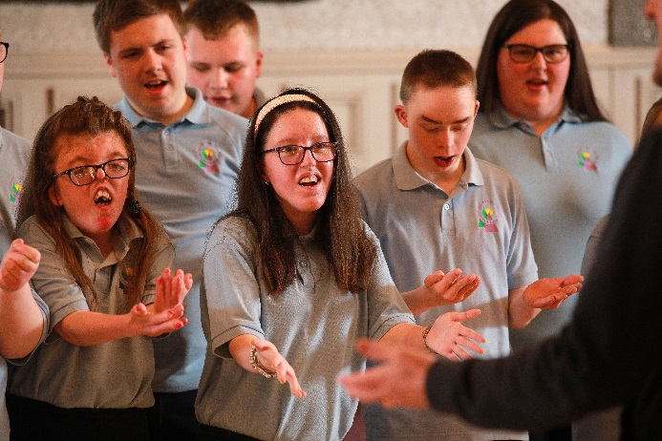
In Sperrinview Special School we believe that having the right ethos is invaluable, writes Paula Jordan, Principal. As a whole staff team, we worked together to agree our school logo, vision, ethos, environment and aims.

Staff, in teams, discussed each area, coming up with strengths and weaknesses within the school. Each group decided the best way to describe what we wanted for the pupils and the school and how we would like this to look. We then shared our findings and agreed the common words and phrases which everyone felt comfortable with.
Sperrinview Special School’s ethos empowers pupils to reach for the stars

These were then translated into the following:

Vision
In Sperrinview we are a school community that offers a quality education where all will be enabled to learn new and exciting skills, encouraged to explore a world of possibilities and empowered to reach for the stars.

Ethos and Environment
- Welcoming
- Happy and caring
- Organised and well-equipped
- Facilitating learning
- Opportunities for fulfilment
- Challenging and stimulating
- Peaceful and calm
- Enriching experiences
- Listening to all
- Developing self

In Sperrinview we aim to
- Provide quality, child-centred, holistic education
- Promote communication
- Develop personal and independent living skills
- Celebrate achievement, building self-esteem and confidence
- Foster links with families, schools and our local and global communities

Staff were presented with the possible wording and agreed that the above would be what everyone wished to work towards.

Staff live by our school motto and strive continuously to uphold our vision, ethos, environment and aims.

Extra-curricular activities contributing to a school’s ethos
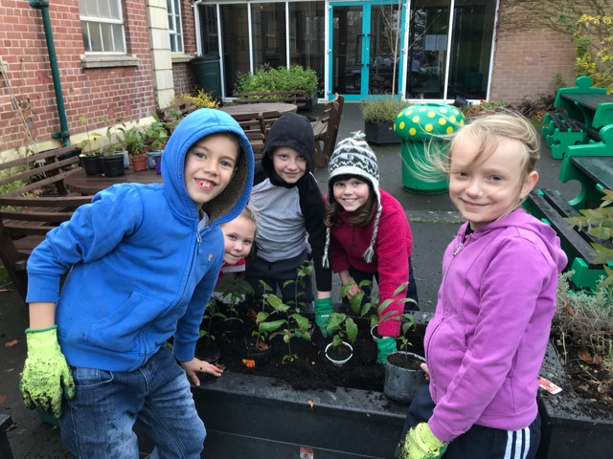
The Armstrong Primary School is a co-educational, controlled primary school situated at College Hill, Armagh, serving the city and its rural hinterland. The school has a current enrolment of 540 pupils accommodated in nineteen mainstream classes and three special needs learning support centres.
A particular feature of the school’s ethos is a strong commitment to a wide-ranging programme of extra-curricular activities, writes David Dickson, Principal. The school aims to develop ‘the whole child’. The primary focus is on teaching and learning but children are encouraged to broaden their knowledge and experiences through participation in the extra-curricular programme – known colloquially in The Armstrong as ‘clubs’.
Participating in clubs help pupils at the Armstrong Primary School to explore new interests and develop skills
Clubs offered include sports – boys’/girls’ hockey, rugby, football, cricket, athletics and badminton etc.; technology, Forest Schools, cross stitch, musical theatre, cookery, art and craft, ICT, French, orienteering, and speech and drama. Generally between fourteen and sixteen clubs are offered each term to P4 - P7 pupils. The clubs are organised after school between 3.00pm and 4.00pm on four afternoons per week with a selection available each day. They are led by teaching staff – not by outside agencies – and are free to attend. All teaching staff including the Principal are involved in leading clubs.
The nature of the extra-curricular programme enables pupils to mix with those from other classes and year groups and gives them the opportunity to get to know a range of teachers across the school. This helps to promote and maintain the strong relationships which are so characteristic of The Armstrong. Children are given opportunities through the clubs’ programme to explore new interests and to develop additional skills. It is hoped that these interests and skills will be carried forward into post-primary education and indeed into adult life.
The after-school extra-curricular programme would not exist without the enthusiasm and dedication of school staff. Teachers ensure that a culture of opportunity and inclusivity continues to be a key attribute in the ethos of The Armstrong Primary School.

Introduction to the CSSC ethos self-evaluation toolkit

Engagement wit h stakeholders
Ethos needs to be living and breathing in a school. It should be evident from the moment that you walk into the building, and permeate through all aspects of school life.
To ensure that ethos is owned by everyone, it is vital that all stakeholders contribute to the development of a school ethos through consultation. Consultation should involve pupils, parents, teaching and non-teaching staff, governors, the wider community and outside agencies who provide support within the school.
Schools are required to give consideration to ethos in the school development planning process, and this needs to be reviewed in connection with the curricular and non-curricular targets within the school.

Evaluation of ethos
Ethos should be evaluated at a time that is conducive to the life of the school. This may be at the start of a school year, when there is a change of leadership, or during the development of the three-year school development plan. What is certain is that it is essential to evaluate the ethos of the school in order to affirm what the school is about and what it aspires to do for its children and young people.
There are many factors that impact on ethos and bring challenges. These may be external or internal, and may include change in leadership, change in composition of school, demographics of the local area, societal influences or educational challenges.
A school’s ethos needs to be strong to stand the test of time and the challenges that all schools face today.

Consultation
Using the material in the toolkit, schools may choose to complete consultations by open discussions with stakeholder focus groups, through questionnaires or a combination of both processes.
If consulting on a new ethos statement, it is essential, after a period of time, to undertake evaluation to ensure that decisions taken at the time of consultation have been implemented. It is also important to evaluate any decisions taken and consider their impact.
CSSC’s ethos self-evaluation toolkit will provide you with resources to:
- develop a statement of ethos through consultation
or
- evaluate the current ethos to consider how it contributes to school life with a view to reflecting on the outcomes from the consultation to further enhance the ethos of the school.

How to use the toolkit

Step 1
Complete the baseline activity
If you do not have a current ethos statement you may still benefit from taking some time to consider how a visitor would perceive your school – what would they see, hear, experience and so on.

Step 2
Decide whether to complete part 1 or part 2 of the toolkit
All materials are available from the e-version of the toolkit, which is available at the CSSC website www.csscni.org.uk.

Step 3
How to proceed
Suggestions for next steps are included at the end of part 1 and part 2, and provide guidance on how to proceed and embed ethos in your school development plan.

Figure 1 displays a flow chart which will help you follow the pathway that is appropriate for your school’s ethos journey.

Please note timescales are only for guidance. Use the toolkit according to the needs of your school.

Figure 1 – Flowchart to guide your school’s ethos journey

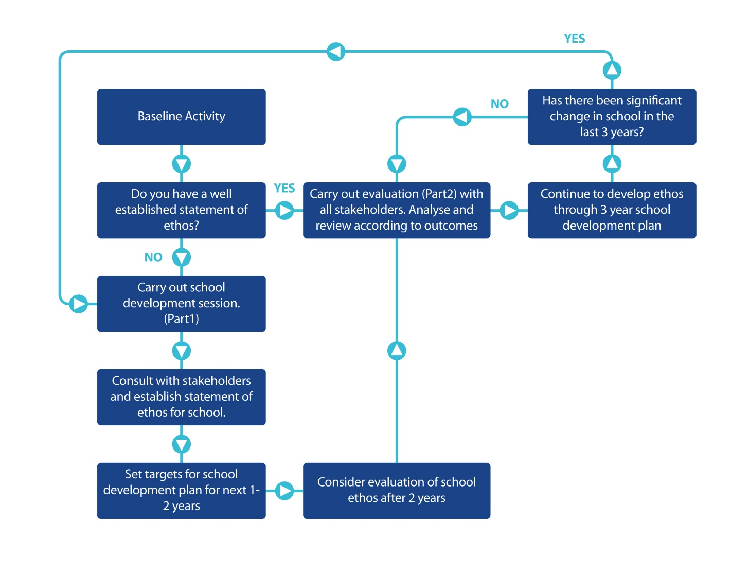
Please note, timescales are for guidance only

Baseline activity

This could be carried out with staff or staff and governors

The current statement of ethos for [insert school name] is:

Some questions to consider:-
- Does this statement reflect what the school aspires to be?

- Is the ethos expressed by the statement evident throughout the school – is it living and breathing?

- If a new visitor came to the school, what would they see/experience?

- What would the visitor say about the school?

- Would the visitor’s interpretation of the school be reflective of what the school aspires to be with the current ethos statement?

- Would the school exceed the expectations of the ethos statement?

- Would the school not meet the expectations of the ethos statement?

Part 1

CSSC ethos self-evaluation toolkit

Consultation on statement of ethos
To establish what your school’s ethos is, it is important to engage initially with all staff, (teaching and non-teaching) and the Board of Governors, as they will drive the ethos of the school and live it on a day to day basis.
To carry out this part of the consultation effectively, it may be conducive to have a whole staff development session and to intermingle discussion as a whole group with small group activities.

School Development Session
Suggested agenda
- Welcome
- Exploration of what ethos is and its importance
- Mission statement, vision and values – explanation
- Consideration of what constitutes an ethos?
- Group collaboration - creating statements of ethos
- Forward planning

Step by step guidance for leading a school development session
Welcome staff and convey the value that their input will make to the development of an ethos statement for your school.
(If possible arrange staff and governors in mixed groups to facilitate open discussion amongst all stakeholders present)

Exploration of what ethos is and its importance
Today you hope to spend a little time considering ethos, its importance and the values that contribute to the ethos.
Webster’s dictionary states that ethos is ‘the distinguishing character, sentiment, moral nature, or guiding beliefs of a person, group or institution.’ (Miriam Webster, 2018).
What are the characteristics of your school? – Discuss in open forum or in groups.
(Questions 1-4 on the handout – Appendix 1)

Mission statement, vision and values – explanation
The mission statement expresses everything a school does on a day-to-day basis.
(Question 5 on the handout – Appendix 1)

The vision statement expresses the aspirations of a school. .
(Question 6, 7, 8 on the handout – Appendix 1)

The core values support the mission and vision. They reflect what a school values and are what you want your children and young people to experience in school, learn and demonstrate on a day-to-day basis.
List the values that you feel are important (Appendix 1).

These three different terms are intrinsically linked and contribute to the ethos of a school.

Take feedback from groups on the outcomes of the discussion activity.

Consideration of what constitutes an ethos - group collaboration activity
Through your ethos you want to establish:
1. a climate that is conducive to all aspects of learning and built on good relationships
2. high expectations - a culture of striving to achieve personal bests
3. an atmosphere of fairness and equity, where everyone is valued
4. strong partnerships - staff, board of governors, parent and wider community.
Take a few minutes to consider some words around these four headings that you believe will encompass what you want for [Insert School Name].
(Complete group collaboration activity in small groups – Appendix 2).

Challenge
Now a challenge. Using some of those words listed in the group collaboration activity, can each group form a statement that reflects the ethos of your school?
Remember ethos should be living, it should be felt as soon as you walk through the door, the welcome you receive, it’s the interactions between different people in the school, how the furniture is arranged, the messages on the noticeboards etc.
(Complete ethos statement activity - Appendix 3).
Take feedback on statements.

The way forward
As a group, discuss the next steps.
By this stage you will have more than one statement of ethos, you will need to consult with all stakeholders (as detailed previously) to ascertain which statement the majority of stakeholders believe reflects the school.
(Appendix 4 provides a letter which can be customised to suit your school and forwarded for consultation with stakeholders in respect of the statement of ethos.)
The voice of the child is critical to the development of the ethos statement and the pupils can be consulted through focus group discussions to help them choose which statement they feel describes their school.
Next it is important to establish one or two targets in respect of ethos for the school development plan.
Initially you may wish to consider how you are going to articulate/promote your ethos in school and externally to the wider community.
In the second year of the school development plan you may wish to establish a target of auditing key policies e.g. pastoral care etc. to insure that the ethos is reflected through them.
In the third year of the cycle you will be ready to carry out rigorous self-evaluation and this will lead you on to the resources in part two of the toolkit.

Appendix 1 – Exploring ethos

Below are some questions to prompt discussion in your group. Please make any notes that you feel reflect your group discussion.

- Who are we? (What is the current background information to the school?)

- What is our history? (What is the history of [insert school name]?)

- Where are we? (Geographical position/consider the community the school serves).

- Where are we on our journey as a school? (Take into consideration recent changes, staffing, pupils, etc?)

- What do we do? (Mission - day to day basis).

- What are our goals for [insert school name]? (Vision – aspirations for those in the school).

- What do we need to achieve these goals? (Resources, changes required, additional support).

- How will we know that our goals for the school are becoming reality? (What outcomes/changes need to happen to affirm that we are achieving the goals?)

List the core values that you would like the children to acquire and demonstrate, through their school experience at [insert school name].

Appendix 2 – Group collaboration

- Climate. (What words describe the characteristics/atmosphere of the school which enrich it as a place where people want to go to?)

- High expectations. (What words describe the expectations you have for the pupils and staff in your school?)

- Atmosphere of fairness and equity. (List words to describe how this is established and expressed.)

- Strong partnerships. (List words to describe who the partnerships are with? How are they developed? Why are they developed?)

Appendix 3 – Ethos statement activity

Using some of the words from the group collaboration activity, create a statement that the group believes is reflective of the ethos of your school.

Appendix 4 – Consultation letter
[Insert school name]
[First line of address]
[Second line of address]
[Third line of address]
[Date]

Dear
Recently, the Board of Governors and the whole staff (teaching and non-teaching) of [insert school name] came together to discuss our school ethos.
Ethos is vital to a school as it reflects who we are and what we are about. It is the rock on which a school is built and should be reflected in every aspect of school life.
With this in mind we would like to consult on the following statements of ethos for our school. We would like you to select the statement which you feel best fits our school. The statement which is deemed to be the most appropriate by the majority of stakeholders will become our new ethos statement for [insert school name].

Please tick the statement which you wish to be our statement of ethos:
[Insert statement 1]

[Insert statement 2]

[Insert statement 3]

(There may be more than three statements for consideration)
Thank you for your support. Please return your response to school by [insert date].
Regards
[Principal]

