Independent Review of Education

Controlled Schools’ Support Council Submission

26 November 2021

Contents

1. Context 2
2. The controlled sector 2
3. Delivery of the Review 3
4. The purpose of education and vision for the future 4
5. Strengths and weaknesses of the current system 4
6. Areas identified of relevance to the controlled sector 5
A - Redirecting the focus to Early Years 5
B – Wellbeing 7
C - The purpose, nature and delivery of the curriculum, assessment and qualifications 7
D - Promoting a whole community approach to education 8
E - Maximising boys’ potential 8
F - Driving forward Teachers’ Professional Learning (TPL) 8
G - Supporting the professional learning and wellbeing of school leadership 10
H - Ensuring Interdepartmental collaboration and delivery 11
7. Conclusion 11

Context

On 15 December 2020 Education Minister Peter Weir MLA announced the publication of the Terms of Reference (TOR) for the Independent Review of Education. The Controlled Schools’ Support Council (CSSC) welcomed the opportunity to present to the Independent Review Panel at an introductory meeting on 20 October 2021. This short document has been prepared following this initial meeting to present some of the wider input provided by our Council and member schools.

The controlled sector

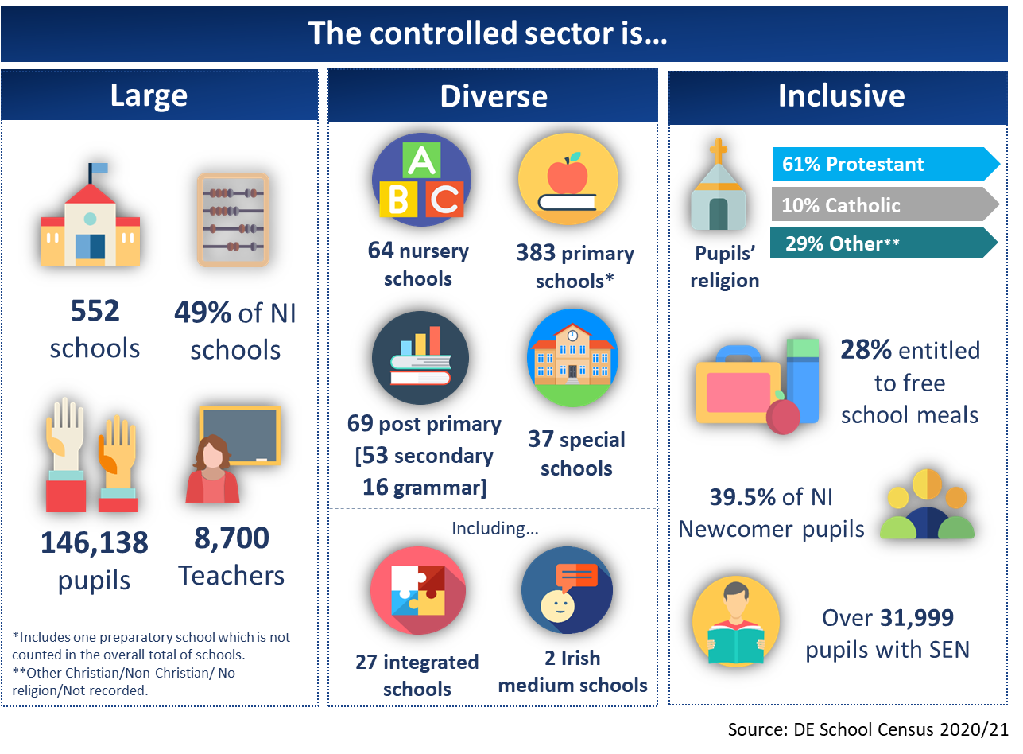
The controlled sector is the largest in Northern Ireland with 49% of the schools and 146,138 children and young people attending. It is diverse and crosses all phases. Controlled schools are open to all. The Education Authority (EA) is the managing authority for controlled schools taking over the responsibilities of the Education and Library Boards through the Education Act 2014. For a number of years the sector has suffered from a deficit of support. The Education Authority (EA) has a role as the overarching delivery body of education policy and service provider for the Department of Education (DE) whilst also having a specific role for controlled schools. The pre-existing deficit of support has been compounded by this dual role, at times resulting in a lack of specific support for schools, for example in the pre and post inspection support process and at others through potential and realised conflicts of interest as in the area planning process.

Since its inception CSSC has prioritised its role in developing and maintaining the collective ethos of the sector. Significant development work has been carried out to develop that ethos and through the Ethos Self-evaluation Toolkit to support controlled schools to have a living ethos throughout the school and into the local community. The role of ethos in the improvement journey of schools and ultimately its effect on the outcomes for our children and young people has been clearly demonstrated and is accepted in policy. This work has been welcomed by controlled schools and is ongoing demonstrating a core need that CSSC has filled.

Further in relation to post inspection, school improvement and leadership development, other schools benefit from the support of officers from both their own managing authority and the Education Authority (EA). An analysis of inspection outcomes from 2009 to the start of lockdown demonstrates that almost double the number of controlled schools entered formal intervention to other schools. In a controlled school the support is provided solely by the Education Authority (EA).

Similarly, through the area planning process the Education Authority (EA) has a dual role having the lead overarching planning role for all schools, but also specifically planning for the controlled schools’ estate. At best this results in some confusion and the potential for criticism in relation to a conflicting role, at worst it leads to a lack of coherent estate planning specifically for controlled schools with the resulting impact on outcomes for children and young people.

Other financial data demonstrates the deficit of support. Controlled schools currently possess the ten largest financial deficits in relation to their delegated budgets. This is mirrored in surpluses with the majority of schools in surplus being of other management types. Likewise in year budget analysis demonstrates that it is controlled schools that are more frequently in deficit.

The deficit of support and resulting implications across the system results in a lack of equality for children and young people in controlled schools. CSSC is working closely with the Education Authority (EA) to challenge its role and support it to become the best managing authority it can be.

Equality of provision must be at the core of our education system. For the reasons set out above CSSC would contend that the present system is not equitable to children and young people attending controlled schools. We would ask the Independent Review Panel to address this inequality in their recommendations. All children and young people need to be treated with equity in relation to their needs and investment must be appropriate and sufficient for those needs to be met.

Delivery of the Review

CSSC welcomes the evidence based approach of the panel. It is important that the review refers to and builds upon a significant body of evidence gathered through various reviews over the past years. We also reiterate that children and young people must be at the heart of any review and any subsequent changes made to our education system.

Schools remain in a challenging context in relation to Covid-19. They are still dealing with ongoing cases and isolations along with staffing shortages, compounded by the need to support ongoing learning whilst mitigating the long-term adverse impact of previous lockdowns. This challenge on schools increases with ongoing system issues and flat budgets for the 2022/2023 financial year.

This education context is set within a wider context of political uncertainty, an election in May 2022 and what can be termed “review apathy”. It is therefore vital that schools are given confidence in this review process and encouraged to engage. CSSC will support and encourage controlled schools to take part, we will also continue to represent their views and the view of the sector to the panel.

The purpose of education and vision for the future

Education is a transformative process with the objective that children and young people have the skills and knowledge to be valued and valuable members of society. It should present children and young people with a clear moral code and purpose with an overt focus on developing resilience and wellbeing. Skills are key given that we are, more than ever, preparing our children for an uncertain and unknown future. Within the Northern Ireland context it is vital that children and young people have an understanding of their community and wider communities and their place in society. It is also important that schools are actively open to all with an inclusive ethos that respects diversity.

There is an aspiration to move towards a “single education system”. The controlled sector, as the most diverse and largest sector in Northern Ireland, is ideally placed to support this aspiration. Northern Ireland has a complex and diverse education system with a variety of school types and sectors. This reflects the history and traditions within Northern Ireland and supports parental preference. However, along with this diversity is the potential for fragmentation in the system which can then be presented as divided and duplicating. Finding a balance between the benefits of diversity but the limitations of potential perceived division and fragmentation is a complex task. Valuing our heritage and traditions, maximising respect and community cohesion whilst providing our children and young people and society more widely with high quality education is at the heart of the current review and we welcome the role of the controlled sector in this.

Strengths and weaknesses of the current system

Strengths:
- Diverse in school types supporting parental preference and the needs of the child
- Collaborative relationships between schools to deliver community solutions for children and young people (e.g. Area Learning Communities, Shared Education Partnerships)
- Some high performing schools with exceptional leaders and teaching staff
- Commitment from a significant body of voluntary school governors

Weaknesses:
- Diversity can lead to lack of equity for children and young people
- Project based solutions with limited short term funding
- Some low performing schools with a stubborn tail of underachievement
- Teaching profession that feels undervalued, unsupported and under developed
- Lack of trust in the system at all levels
- At times confused communication between system leads and school leaders – a sense of disconnect
- Lack of community approach to supporting the development of children and young people
- An over focus on one type of examination based outcome

Areas identified of relevance to the controlled sector

CSSC supports and endorses the findings and eight recommendations from the recent A Fair Start report and action plan. These eight recommendations need to be implemented system wide with investment provided over a significant period of time. A short term attempt to solve systemic issues will not provide the outcomes required. CSSC has provided some specific commentary under the key headings of that report, demonstrating our support but also providing issues raised by Council and school members. Many of the comments provided have come directly from practitioners within the controlled sector, there is some repetition in the points but CSSC felt it important that the Independent Panel received the input as provided. Through these headings we attempt to provide input to the key strands of the review in relation to the Journey of the child, the support required and system design.

- Redirecting the focus to Early Years.
- Championing emotional health and wellbeing.
- Ensuring the relevance and appropriateness of curriculum and assessment.
- Promoting a whole community approach to education.
- Maximising boys’ potential.
- Driving forward Teachers’ Professional Learning (TPL).
- Supporting the professional learning and wellbeing of school leadership.
- Ensuring interdepartmental collaboration and delivery.

A - Redirecting the focus to Early Years
The Early Years are a fundamentally important stage of learning and development. The controlled sector has a significant number of nursery schools and nursery units within primary schools across the country:

- It is vitally important to develop the childcare strategy quickly, but with due consideration and consultation to ensure that it is fit for purpose and will provide support for every child and family to engage with education and have improved outcomes.

- Research has shown that the early years are the most important in embedding learning and creating positive experiences of education. This should be a partnership between parents and nursery / preschool providers with opportunities for parents to develop their own parenting skills to better support the development of their children.

- The CSSC supported Thrive Project in Rathcoole and Monkstown, provides a clear example of a consistent approach to creating key links between local parents, schools, community groups and statutory and voluntary organisations to assist them to work together to help children and young people do well. The Solihull Approach is fundamental to its success. This is an example of good practice which should be shared, replicated and adapted across our schools and communities.

- Penultimate age children - consideration must be given to penultimate age children in nursery provision and the impact this has on overall provision. In reality nursery schools require these admissions to fill limited spare capacity for funding, but there needs to be a change to the legislation so that these younger children aren't offered places until closer to the beginning of the new school term when unplaced target age children have had a chance to fill that capacity. Penultimate age children should not displace target age children neither should they divert funding from elsewhere.

- Developing relationships - there is a need to consider collaboration between government departments regarding Early Years provision, particularly the Department of Health (DOH) and the Department of Education (DE). This is equally applicable in the area of Special Educational Needs provision. The early identification, diagnosis and provision for children enables professionals to make interventions early in the learning journey and would potentially lead to improved outcomes for the children and also financial savings later in their school life.

- School starting age - consideration should continue to be given to children starting primary provision later or there should be flexibility around the starting age. The ongoing consultation in this regard is welcomed. Parents should be involved in this process as they are more aware of the needs of their child. There is a need for more evidence and a detailed consultation in this area.

- Transitions to P1 need to be more standardised so that all P1 teachers take cognisance of the skills, attitudes and knowledge developed in the pre-school setting, and don't just take the children back to basics. Settling in times, length of school day, equipment and resources provided are all areas that need to be addressed.

B – Wellbeing
- Children at potential risk - there are concerns about the length of time it takes to respond to children in life threatening need. The Thrive project already mentioned demonstrates good practice in this area.
- Impact of Covid-19 - consideration must be given to the social and emotional wellbeing during and post Covid for pupils and staff. Early investment saves money later.

- Standardise approach across schools – health and wellbeing services available to children differ across schools. Current disparities are linked to funding and difficult choices made by school leaders and need to be addressed so that all children and young people are treated equitably. Health and wellbeing of children and young people should not be subject to the budget status of a school.

- Consideration should be given to international models of health and wellbeing support. There are effective exemplars of multi-agency approaches with a team built around the child providing appropriate support in education, health, wellbeing.

- Provision for parents and carers who do not have access to digital platforms or indeed to bank accounts needs to be retained. Free school meals applications are now solely online. It should be 'digital first' - not 'digital only'.

C - The purpose, nature and delivery of the curriculum, assessment and qualifications
- Post primary teachers are currently trained through subjects, there needs to be a greater emphasis in training to ensure that all teachers understand that their first priority is to prepare pupils for life and become valuable and valued citizens. Learning happens best when it is seen as relevant to interests and aspirations of the pupils so having a one size fits all curriculum means many pupils see limited value in their studies. Children’s needs should be at the centre of the curriculum with more flexibility with priority given to core skills such as literacy, numeracy and value given to practical and vocational subjects.

- Curriculum review at GCSE and A Level - the curriculum at KS4 is focussed on examination outcomes, compared to the primary curriculum and KS3. It is important that the curriculum meets the needs of all children and young people and the wider needs of society.

- There is a need to consider how achievement is measured - Current measures of success are limited, focused mainly on the attainment of 5 GCSEs A*- C, including English and Maths, rather than a pupil’s potential. This focus skews education provision and gives less emphasis to the value-added element of the learning process for many pupils.

- The over reliance on subject based exam results should be widened to include the attributes and disposition that we want children to develop. Valuing creative attributes and practical skills often are overshadowed by GCSE and A level results.

D - Promoting a whole community approach to education
- Ethos work and toolkit - The importance of school ethos is a key factor in the raising of standards and the development of leadership skills at all levels within the system. CSSC has produced an ethos toolkit for controlled schools which is supported by whole school workshops. This will support ‘leading ethos’ which is recognised as a key domain of leadership practice. CSSC is well placed to develop ethos across all aspects of the controlled sector.

- Comments have already been made under the Early Years section about the need for a whole community approach to support the child. The whole community includes all services and all stakeholders. Again the Solihull Approach demonstrated in action through the Thrive Project provides an exemplar of good practice.

E - Maximising boys’ potential
- Research from Ulster University has demonstrated that working class boys’ experience “compounded educational disadvantage”. Evidence has also demonstrated that this is significant in protestant working class communities.
- The Taking Boys Seriously project, co-supported by CSSC, has worked through research and practitioner support to develop and test a set of holistic ‘relational’ educational principles aimed at igniting boys’ motivation, aspirations and attitudes towards education and learning. The further implementation of these principles at a system level to support schools to support boys in maximising their potential must be prioritised. The Thrive Project again is an exemplar of this is action.

F - Driving forward Teachers’ Professional Learning (TPL)
- Quality of teachers – confirmed by research the quality of teachers is the single most important factor in the education system. The Proposals for Teacher Professional Learning within Northern Ireland (GTCNI) presents a professional pathway for teachers in their professional development, which suggests a level of investment in the teaching profession. The concept of a ‘Leading Teacher’ and/or ‘Excellence in Teaching’ is a recognition which could act as a standard mark for the profession. The Chartered College of Teaching, a recognised UK body, could be an aspect which is linked to this concept and actively promoted within the NI teaching profession.
- The role of teacher training and continuing professional development must not be overlooked. Northern Ireland has a shortage of teachers in specific subject areas, young teachers constantly employed through temporary contracts and schools that cannot get substitute teachers when required. There are large class sizes and many schools with as many classroom assistants as teachers. There is no required up-skilling of teachers after their induction and early professional development and while all have to be registered and undergo appraisal there is limited support for school leaders who identify under-performing teachers. A seamless programme of initial training, early professional development and continuing professional development is required to address this. Investing in the teaching profession is investing in children and young people.

- Teachers are the best resource within a school and school leaders need to uphold professional standards and encourage staff to be innovative and creative in their teaching. Access to professional development across subject areas has been increasingly diminished over the last 20 years and although there has been an increased focus on school development this tends to be at a strategic management level with less emphasis on the practice within the classroom.

- The Proposals for Teacher Professional Learning within Northern Ireland (GTCNI) offers a potential structure to address some of this but there needs to be a coherent and structured training programme in place addressing strategies and methodology for practice within the classroom, particularly in key skills such as Literacy and Numeracy as a minimum within the primary sector.

- In order for any professional development structure and its accompanying programmes to succeed there needs to be sufficient resources in place to enable schools to avail of Teacher Professional Learning opportunities. A dedicated Teaching Professional Learning budget, supplemented where possible by school budgets, would allow schools a degree of autonomy in targeting staff development relevant to their needs.

- Inspectors have a role in upholding standards and where a school is falling short there must be immediate intervention to address these issues. The inspection process is often seen as stressful and driven by bureaucracy. It is important to look for evidence but streamline the process and have it seen as a critical friend rather than a fault finding exercise. School improvement is a developmental process.

- Classroom assistants make a huge impact on supporting children’s learning and development - they need to be valued professionally by the leadership with a commitment to investment in their professional development.

G - Supporting the professional learning and wellbeing of school leadership
- School leaders need to be supported with continuing professional development a compulsory part of their appraisal. They need to be supported with key tasks such as school budgeting and to assist them to make the hard decisions about where and how money is spent.

- The professional development path for leadership within schools has been lacking in structure and direction over recent years. The dismantling of the Professional Qualification for Headship (PQH) provision, with no obvious successor has left a void for development between middle and senior leadership. Uptake to a structured professional development programme at this level has mostly been through university provision, which involves significant monetary commitment. Headship requires a different skill set than teaching.

- Provision of continuing professional development through the Education Authority (EA) has continued to some extent at middle management level through Steps and Pathways with ad hoc courses / provision for Principals. There is a need for a designated professional learning pathway to headship with an ongoing programme of professional development for senior leaders to enable knowledge, skills and professional dialogue to be honed and refined.

- Nursery school Principals desperately need funded Principal release time. There are many initiatives being rolled out and it is increasingly difficult to find out about and assess them and try to implement them in school, especially when there are no Vice Principals or staff with responsibility points to support some of this work. There are serious equality and health and wellbeing issues inherent in this.

- The professional pathway for Teacher Professional Learning within Northern Ireland needs to offer a defined structure for new Principals and for more experienced Principals, offering both challenge and recognition to their ongoing professional development throughout their careers.

- CSSC has sought to develop access to this professional learning journey through the provision of a scholarship to the ‘Excellence in Leadership’ programme run by the Chartered College of Teaching.
- Building Capacity Programme – CSSC’s Building Capacity Programme has been well received by controlled schools, it has focused on using research and sharing good practice with the aim of building leadership capacity across middle and senior leadership in school and ultimately raising standards. The programme has facilitated senior leaders to engage with raising standards within their own schools as well as participate in international collaborative work to compare and contrast working practices from other leading European nations.

- The development of the CSSC Ethos Toolkit offers a fundamental review approach to an essential and vital area of any school - ethos. CSSC is now seeking to develop the toolkit to look at how ethos can be developed at all leadership levels across the school system.

H - Ensuring interdepartmental collaboration and delivery
- Cross sectoral working and communications, supports relationship building and signposting. Collaboration currently exists between sectoral bodies at all levels. However, the landscape can at times be confusing to parents and school leaders. It is important that the roles and responsibilities of support bodies are clear and equitable in relation to the needs of the school and more importantly the children and young people.
- Avoiding duplication specifically in relation to the impact on school leaders and their time is vital. Positive moves have been made however schools will often receive similar and sometimes divergent communications from the Department, the Education Authority (EA) and their sectoral support body.

- In the area of Initial Teacher Education there needs to be ongoing collaboration between the four Northern Ireland based providers and schools and support bodies and government to ensure that the teachers are prepared to support the outcomes desired by the system.

- The model of collaboration for school improvement through shared education at a school level should be brought to the system level.
- As discussed already the need for cross government department support in relation to Early Years and special needs provision is vital. This is also the case for the Departments of the Economy and Education in relation to the Entitlement Framework and its delivery in collaboration with Further Education Colleges.

- CSSC and the Education Authority (EA) need to continue to work effectively together to both manage and support the controlled sector. Ensuring that the needs of the children and young people in our schools is not lost through wider system level delivery is paramount and key to the role of CSSC.

Conclusion
In conclusion CSSC very much welcomes this Independent Review and commits itself to assist in any way possible. The diverse and inclusive ethos and nature of the controlled sector demonstrates that it is firmly placed as part of the future of education within Northern Ireland. The significant work already undertaken in relation to underachievement combined with the 3 to 19 spread of our schools also identifies controlled schools as being a significant partner in any recommendations. Pathways from Early Years through to KS5 and onwards are delivered by the controlled sector. A whole community approach to the valued and valuable future of children and young people is the commitment of the sector and more widely in collaboration with other sectors, for all children, with equality of provision at the core of our education system.

https://www.csscni.org.uk/schools/ethos-self-evaluation-toolkit
See separate document already shared – The importance of ethos for school improvement
https://www.education-ni.gov.uk/publications/fair-start-final-report-action-plan
https://thrivenewtownabbey.co.uk/#
https://solihullapproachparenting.com/about-us/

